**SQL Homework – 04** Fani Shundovska

1. --We need **to** **count** **all** orders **for** **each** ship city

**in** which the **month** they are shipped **is** **from** August **to** December regardless **of** the **YEAR***--*

**SELECT** ShipCity, OrderDate, ShippedDate, **COUNT**(*) **AS** order_count

**FROM** orders

**WHERE** **MONTH**(ShippedDate) **BETWEEN** 8 **AND** 12

**GROUP** **BY** ShipCity

**ORDER** **BY** **MONTH**(ShippedDate);

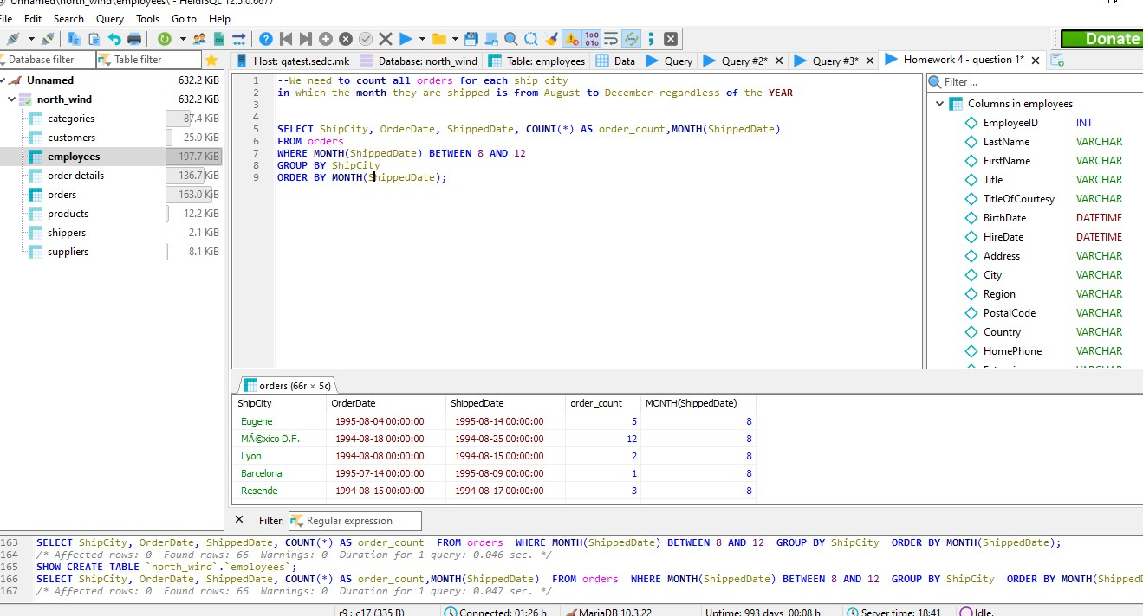

2. **List** **all** the employees that are **from** UK **and** their difference

**between** birthdate **and** hiredate **is** **less** **than** 30 years.

**SELECT** FirstName, LastName, Country, BirthDate, HireDate

**FROM** employees

**WHERE** Country = 'UK' **AND** **TIMESTAMPDIFF**(**year**, BirthDate, HireDate) < 30;

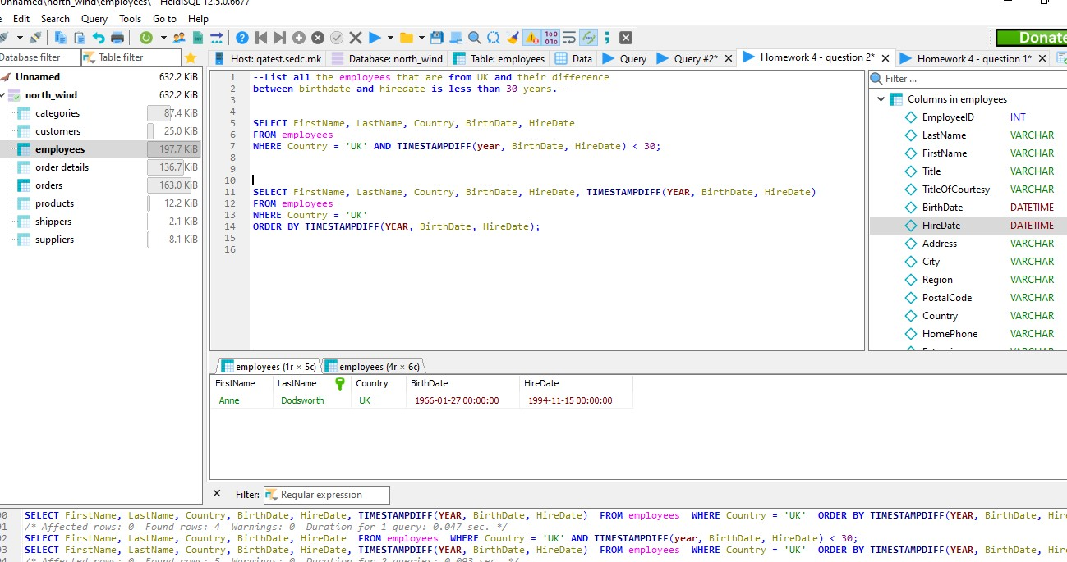

3. We need to list the shipper Id and the company name that has Freight bigger than 1000 (Hint: with subquery)

--We need **to** **list** the shipper Id **and** the company **NAME**

that has Freight bigger **than** 1000 (Hint: **with** subquery)*--*

**SELECT** ShipperID, CompanyName

**FROM** shippers

**WHERE** ShipperID **in**

(**SELECT** ShipVia

**FROM** orders

**WHERE** Freight >1000);

**SELECT** *

**FROM** orders

**WHERE** Freight >1000;

**SELECT** *

**FROM** orders

**WHERE** Freight >1000

**ORDER** **BY** Freight **desc**;

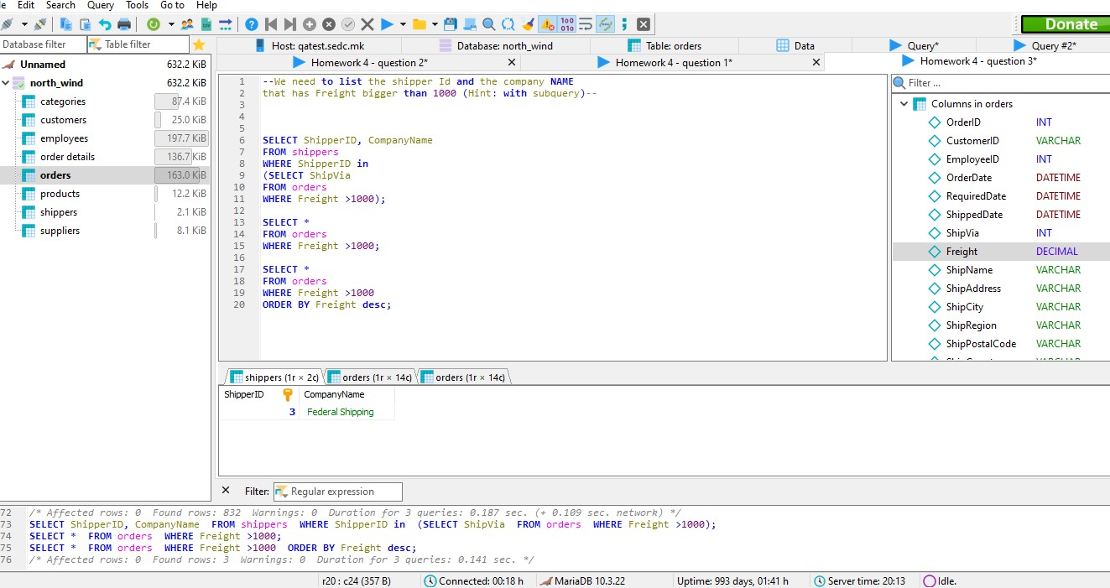

4. Write a query that will list the company name and the city in which their required dates for their orders is in September 1994.(Hint: with subquery)

**SELECT** CompanyName, City

**FROM** customers

**WHERE** CustomerID **IN** (

**SELECT** CustomerID

**FROM** orders

**WHERE** **MONTH**(RequiredDate) = 9 **AND** **YEAR**(RequiredDate) = 1994);

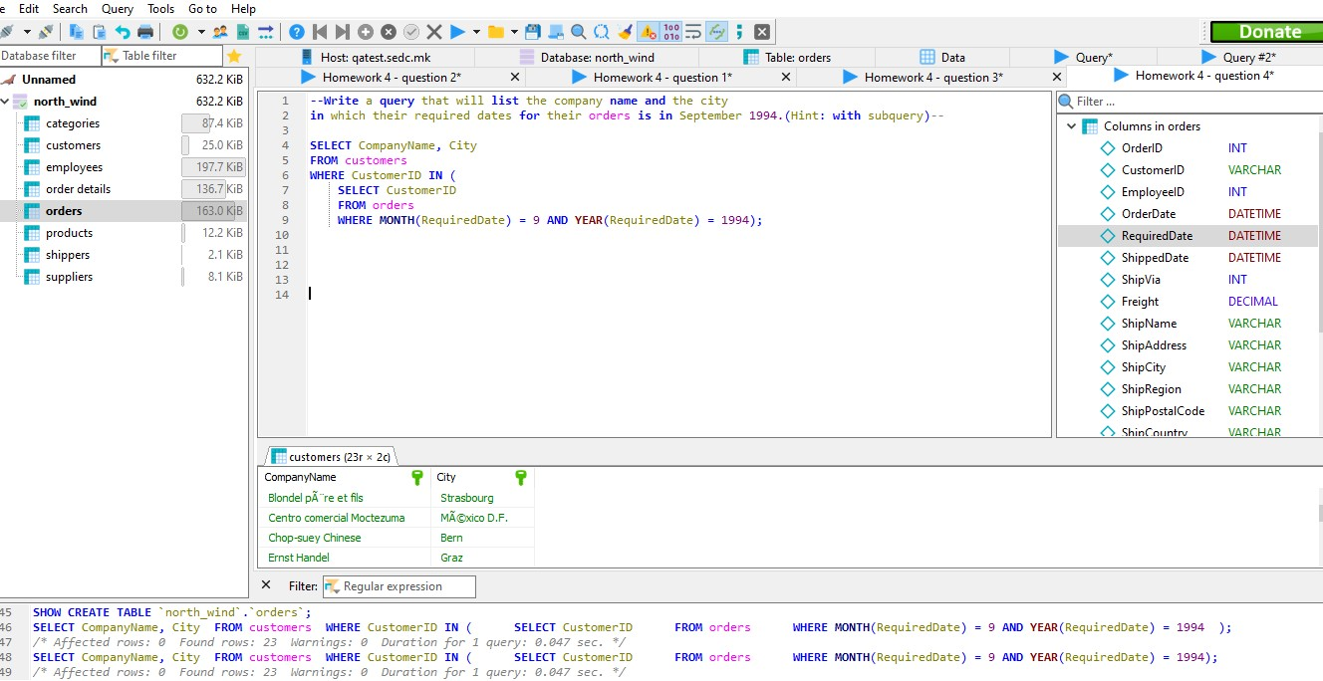

5. **List** **all** the orders **in** which the difference **between** the shipped **date** **and** the required **date** **is** 30 days

**SELECT** OrderID, ShippedDate, RequiredDate, **DATEDIFF**(ShippedDate, RequiredDate)

**FROM** orders

**WHERE** **DATEDIFF**(RequiredDate, ShippedDate)=30;

**SELECT** *

**FROM** orders

**WHERE** **DATEDIFF**(RequiredDate, ShippedDate) =30;

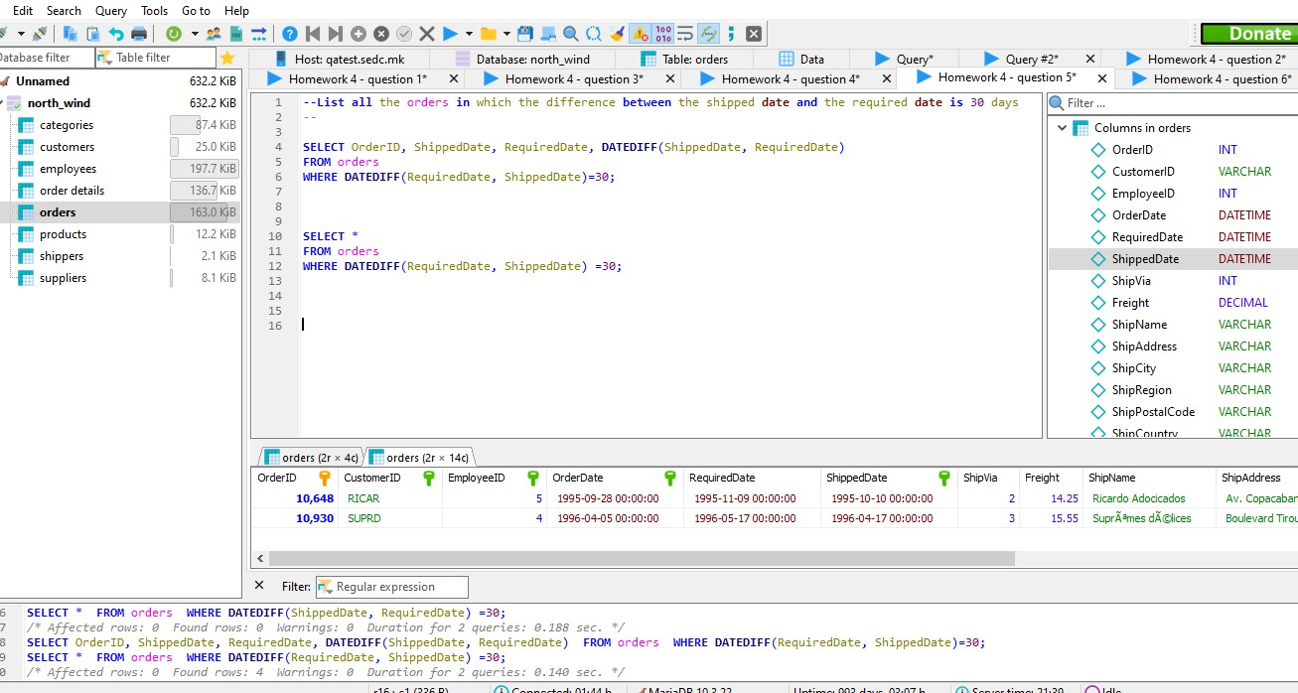

6. We need to write a query where we will list the first name, last name and title that live in London and made orders in 1995.(Hint: with subquery)

**SELECT** FirstName, LastName, Title, City

**FROM** employees

**WHERE** City ='London' **AND** EmployeeID **IN**

(**SELECT** EmployeeID

**FROM** orders

**WHERE** **YEAR**(OrderDate)= 1995)

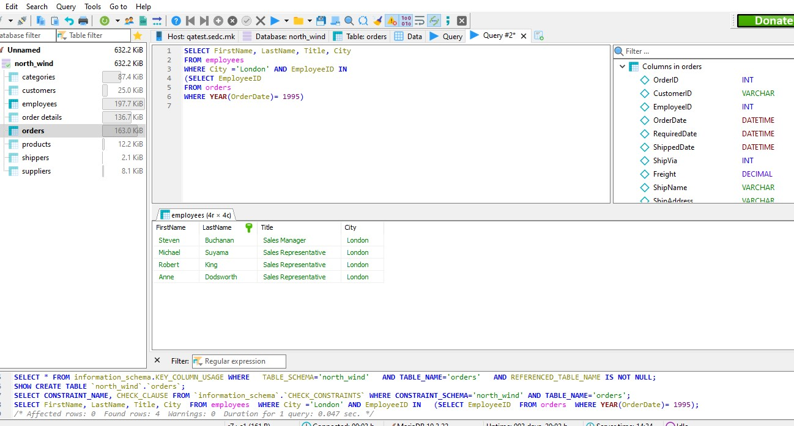

**SELECT** CompanyName, ContactName, ContactTitle, City

**FROM** customers

**WHERE** City ='London' **AND** CustomerID **IN**

(**SELECT** CustomerID

**FROM** orders

**WHERE** **YEAR**(OrderDate)= 1995)

